3-2 Assignment: Android Studio Introduction

CS 360 Mobile Architect and Programming

Nicholle Caudy

5/19/2025

**Create a new Android Studio project with no activity.**

* Name the project and include name in the title.
* Select Java as the language.
* Select API 34 as the target SDK.
* Select Groovy DSL as the build config.

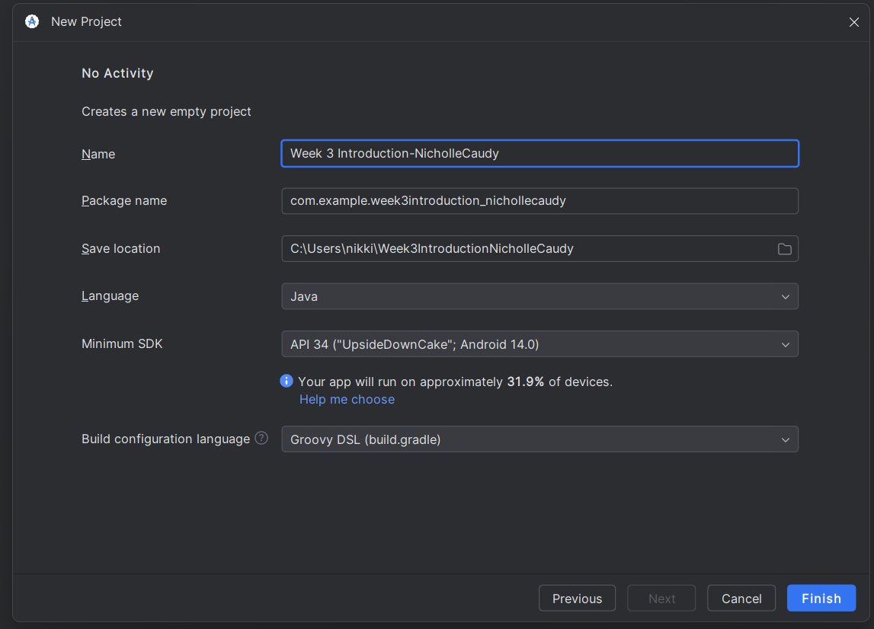

* Create a layout folder within res.
* Create a new file titled “activity_main.xml.” Create a new layout of your choosing which must include a button, a TextView, and a plain text.

**Identify the Android Studio elements using relevant names.**

* Name the button’s text as “Say Hello.”
* Label the ID of the button as “buttonSayHello.”

* Label the pPlain tText as “nameText.”

* Remove all text from the TextView.
* Label the TextView as “textGreeting”

**Discuss any challenges experienced with Android Studio**

* Now that you have explored Android Studio, talk about your initial experience and ask any questions.
* Explain any challenges you are having accessing or using Android Studio so that you will be prepared for later work in this course.

When I first started this assignment, I must admit I was a bit lost. I was afraid to press the different options because I was worried, I was going to lose what I had already accomplished because I would not be able to find it again. After creating the new project and setting it up as specified in the rubric the environment was in the design window. I was confused because I could not see the code for the layout specifications. However, this is an amazing tool when setting up the desired layout. I was able to drag and drop my layout items where I wanted them, change the colors of the background, button, and text. When using this tool, I was getting a warning that I had a hardcoded text, I was able to create a res folder with a strings.xml file to store my strings for this assignment and the warnings went away. After exploring, hovering over the various icons, and gaining confidence I was able to find the option to see my code and the split screen option (also a great tool). I did play around with the IDE and added a few things that were not specified on the rubric, but I liked the way it looked, for example I added “Name” to the EditText or plain text, added android:hint = “Enter name here”, and an auto fill hint. When I entered “Name” into the text field I was getting warnings about the hint and auto fill hint items so I added them to see what would happen. I have included screenshots of all the code for the different items so feedback would be easier for me to understand.